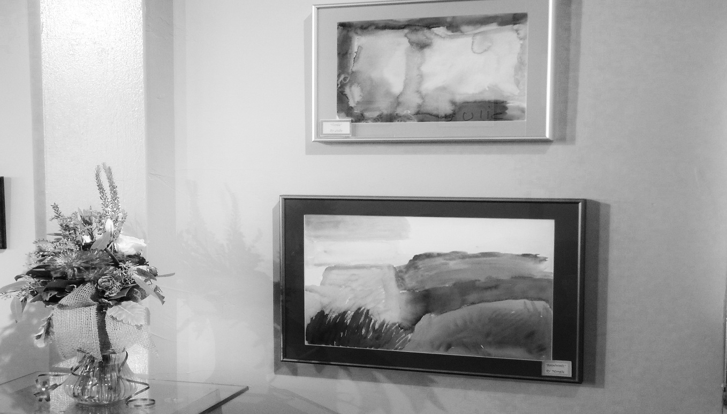
Consumers, Family, Staff & Providers
Starpoint
Artists Reception/Creative Mixer
January 8 at 5:30 pm
Salida Steamplant
Paquette Gallery
220 W. Sackett Ave.
If you have questions, please call Jeamie, Tom, Deb or Bill 539-2577

